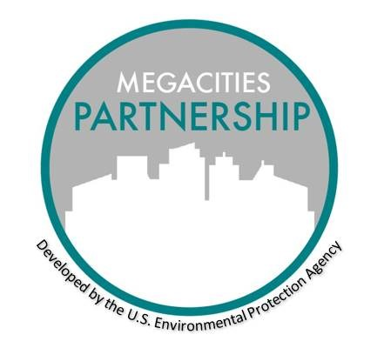

MEGACITIES PARTNERSHIP

Air Quality Management Plan (AQMP) Launch Event Agenda Template

May 2021

AQMP Launch Event Details

Objectives

* Introduce draft air quality management plan (AQMP), air quality standards, and air quality goals to relevant national and local-level stakeholders and the public
* Discuss implementation strategy of AQMP across sectors
* Present health and economic benefits of AQMP
* Receive feedback, comments, and commitments from stakeholders

Outputs

* Engage local, national, and international agencies with AQMP goals
* Encourage interest within external funding agencies to continue support of AQMP with the Megacities host agency
* Begin implementing AQMP

Audience

* Local and national agencies that will be responsible for implementing AQMP
* Representation of local citizens
* International donors
* Press

Possible Launch Event Topics and Presentations

* Introduction to AQMP in Megacity
* Health and economic benefits of AQMP
  + In conjunction with separate presentations detailing methods and assumptions of analyses and findings
* Sector specific presentations, including discussion of implementation planning and financing.
* Present results of additional analyses conducted during the Partnership. Example analyses include lab analysis, source apportionment, or emissions inventory results.