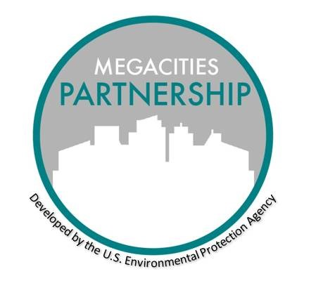

MEGACITIES PARTNERSHIP

Implementation Project Template

May 2021

# Objectives

After an Air Quality Management Plan (AQMP) is launched, the city and stakeholders should try to take action to improve air quality, ideally by implementing a project that supports one of the AQMP objectives and has been identified by stakeholders as an important area for action. Either the city agency, or another implementing partner can work with a local group to move forward a pilot project under the umbrella of air quality management. Specific implementation objectives may include:

* Air quality monitoring or mitigation technology employed in the community
* Distribution of educational materials such as documents and videos created during the pilot project.

# Project Selection Process

Start by soliciting bids from local organizations that are suited to carry out the work (e.g., non-government organizations, grassroots movements). Selection of a local subcontractor follows these steps:

* 1. Expression of Interest phase: Bidders (local organizations) present initial project and budget proposals. A few finalists are selected to present Best and Final Offers (BAFOs) through a competitive review process.
* 2. BAFO process: Each of the remaining groups must clarify/revise bids.
* 3. Formal evaluation of BAFO bids: BAFOs are assessed based on staff qualifications, quality of technical approach, and bid price by a panel of project stakeholders including the host organization, funding organization, and others qualified to assess the quality and logic of the bid, the appropriateness of the proposed staff and staffing plan, and the likelihood of the idea proposed succeeding.
* 4. One organization is selected for partnership; others are notified of the selection.

# Project Proposal Components

The proposal is created by the selected Megacity Partner organization and should include an overview/profile of the organization and key staff, background on the existing local air quality problem, the direct objective of the air quality management project, the work that will be carried out, and the intended/expected result.

The Project Proposal should answer these questions:

* What work will be conducted?
* Who will be involved?
* What is the budget and how will the budget be allocated?
* What is the timeline for this project?

# Pilot Study Planning

An air quality improvement pilot project may include a preliminary data collection phase centered around a particular practice (e.g. open burning, inefficient fuel combustion) that contributes to local air pollution. It should set the groundwork for the study and may determine:

* What actions must be taken to improve air quality? What behaviors must change? What equipment might need to be purchased or improved?
* What are the roadblocks/challenges that may be faced in taking these actions (e.g., inadequacy of current air pollution regulatory framework, availability of clean fuels, sufficient infrastructure for waste management)?
* How would the community react to these actions? Would they be willing to alter their behaviors to reach project goals?

Other community outreach activities include:

* Holding a capacity-building workshop with local representatives and leaders to generate and share ideas for the pilot project
* Hosting focus groups with key industries to assess workers views on the air quality topic for this specific location.

# Pilot Study Implementation

The partner organization will work with local organizations and businesses identified in the project proposal as well as the city host agency to facilitate the pilot study and related tasks according to the project proposal and findings from community outreach actions. Adjustments to the approach may be needed during this phase as new information becomes available throughout the project duration, including information on the effectiveness of the intervention.

# Final Project Report

Following the implementation of the air quality management project, the local partner organization should create a report to document the outcome of the project. The report should include summaries of each stage of the project, including

* Project stakeholders and target group
* Objective(s)
* Implementation – what was done, where, and with whom
* Outcome/accomplishments
* Challenges/limitations
* Impact assessment survey
* Recommended follow-up activities and suggested actors/sponsors for follow-up